Day04&05 - Task02 - Basic linux commands & operations using linux

1. Create user with name Techie and provide sudo access to user.
Ans. To create a user named ‘Techie’ and provide admin access to the user, follow the below commands and steps.
Dependencies:-
- A linux system/server with admin/root access privileges.
- Terminal : To run the commands.
Steps:-
- whoami - This command is used to know the current user
- id - This command is used to view/know the user identity, numeric identifiers, and group memberships for the current user or a specified account
- cat /etc/passwd - This command is used to know get the detailed list of users created/present in the server.
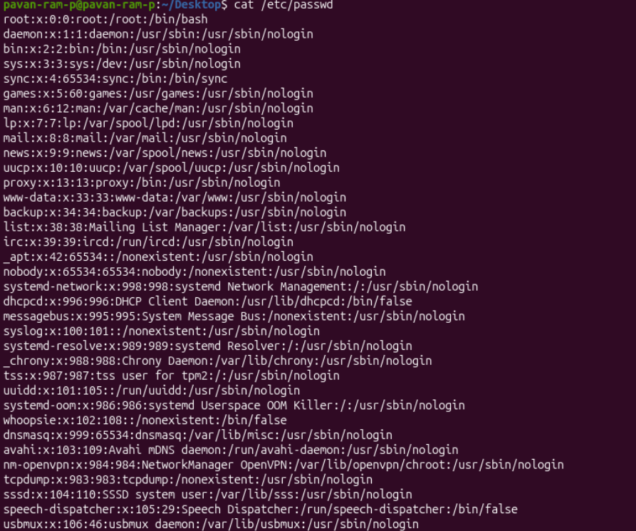
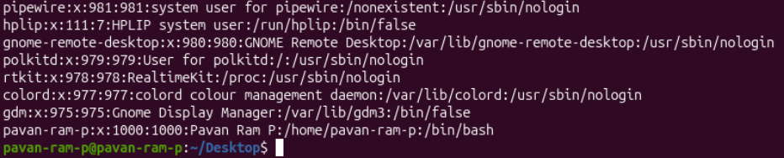
- adduser - This command is used to create a new user
Note: As you see in the below screenshot, the current user does not have the privileges to create a new user, Hence the fatal error: ‘Only root may add a user or group to the system’. So to create a user with admin/root privileges, we use sudo - - ‘super do’.
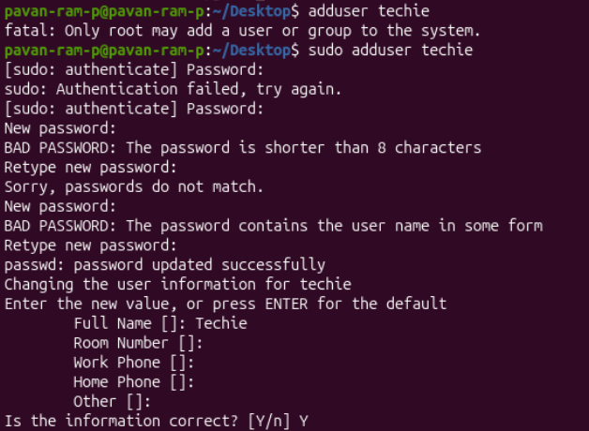
Below are the steps confirming that a user named ‘techie’ is created.
- groups - This command is used to show the user groups present in the system/server
- sudo -l -U <user_name> - This command is used to show the sudo permissions and commands the user is allowed to run with elevated privileges.
Note: In our scenario, this command lets us know that the user ‘techie’ has no admin/root privileges with the output ‘User techie is not allowed to run sudo on pavan-rm-p.’
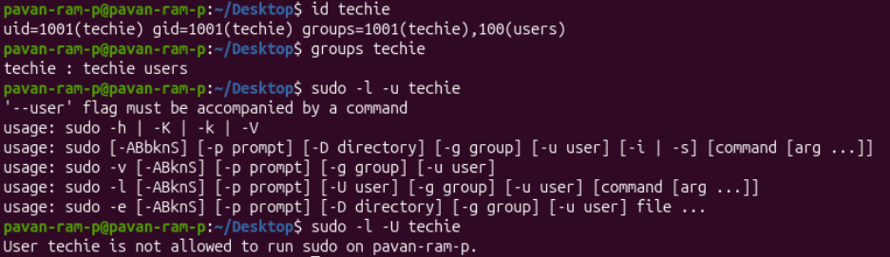
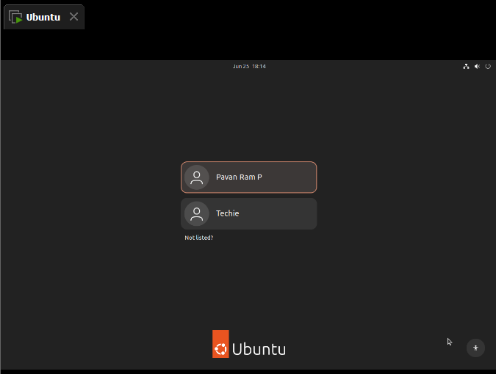
Now we use the below commands to grant sudo/administrative privileges to the user ‘techie’
- sudo usermod -aG sudo <username> - This command is used to add the user ‘techie’ into the sudo user group
  - -a → Append the user to the specified group(s) without removing them from their existing groups.
  - -G → Specifies the supplementary group(s) to which the user should belong.
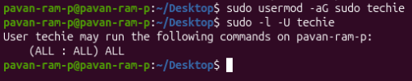
Note: Besides adding directly into the group, we can also edit the sudoers file by following the below commands.
- sudo vi sudo - This command is used to edit the sudo file, once the file is in editing mode,
  - 0/i/INSERT - to enter into the insert mode
  - Techie ALL=(ALL:ALL) ALL = This text should be placed in the sudo file to grant the user ‘techie’ sudo/administrative privileges.
  - ESC/CTRL-C - to exit from the ins ert mode
  - :wq - to save the changes and exit from the file.
Note: Once the above process is completed, the user ‘techie’ will have sudo/administrative privileges.

2. Navigate to the home directory..
- cd ~ - This command is used to navigate to the current user's home directory.
- pwd - This command is used to know the ‘present working directory’
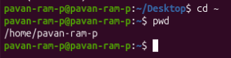
3. Create a new directory..
4. List the contents of a directory..
5. Change the current directory..
- mkdir - ‘make a directory’ - This command is used to create a new directory
- ls - This command is used to list all the files and folders present in the current directory
- cd - change directory - This command is used to change the current directory
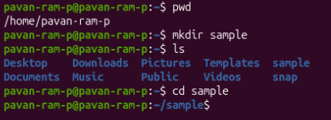
6. Create a new empty file..
7. View the contents of a file..
- touch - This command is used to create a new empty text file
- cat - This command is used to view the contents of the file
- vi - This command is used to edit the contents of the file. This one acts as an text editor for the file.
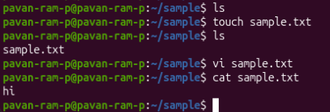
8. Copy a file to another location..
- cp <file_name> <destination> - This command is used to copy a file from one directory to the specified destination directory
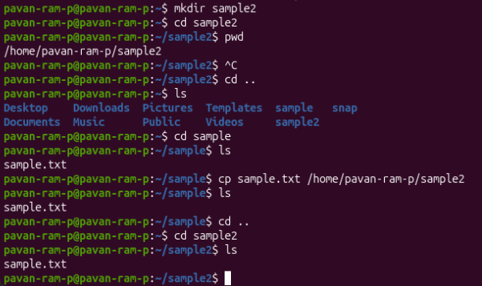
9. Move a file to another location.
10. Rename a file..
11. Delete a file..
- mv <file_name> <destination> - This command is used to move a file from one directory to the specified destination directory
- mv <old_filename> <new_filename> - This command is used to rename the old_filename to the new_filename
- rm <file_name> - This command is used to remove or delete the file from the current working directory.
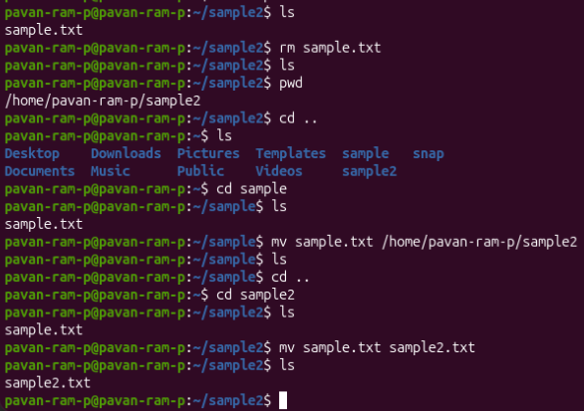
12. Grant or revoke permissions on a file or directory..
- chmod - This command is used to change the permissions of the file or directory
Note: The permissions can be granted using numbers and variables. In most occasions variables are used while revoking a single permission to an entire user/group/others. But numbers are the conventional method used to grant or revoke permissions
- Permission Symbols Reference
u → User/Owner
g → Group
o → Others
a → All (user + group + others)
r → Read
w → Write
x → Execute
Operators:
+ → Add permission
- → Remove permission
= → Set exact permission

- Numeric Permissions
Read (r) = 4
Write (w) = 2
Execute (x) = 1

Add the values to get the required permission:
7 rwx (Read, Write, Execute)
6 rw- (Read, Write)
5 r-x (Read, Execute)
4 r-- (Read only)
0 --- (No permission)

In a chmod command, three digits are used: chmod XYZ filename
X = Owner permissions
Y = Group permissions
Z = Others permissions
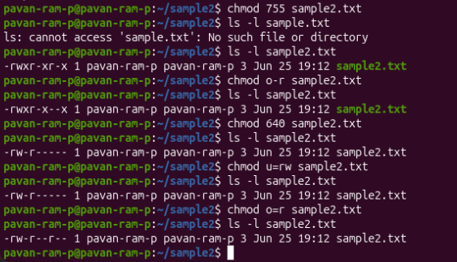
13. View the current date and time..
14. Check the system uptime..
- date - This command is used to know the current date, time and timezone.
- uptime - This command is used to display how long the system has been running, the current time, number of logged-in users, and system load averages.
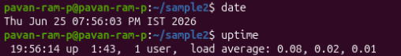
15. View the running processes..
16. Kill a running process..
- ps -ef - This command is used to display all currently running processes on the system with detailed information.
- ps -ef | grep <process_name> - This command is used to display the specified process.
- top - This command is used to show running processes in real-time, along with CPU and memory usage.
- kill <process_id> - This command is used to kill a prcoess
- pkill <process_name>- This command is used to kill a process using process name
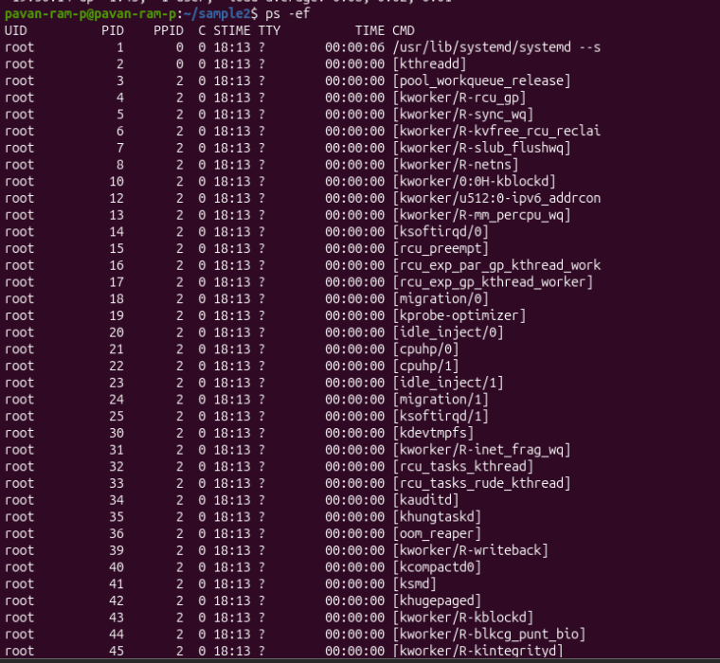
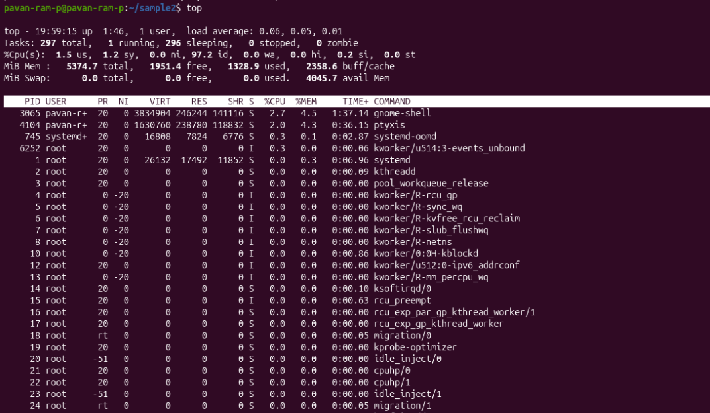
Note: In the below picture, the process ‘sleep 300 &’ which starts a new background process that runs for 300 seconds is created and later is killed using pkill and kill commands.
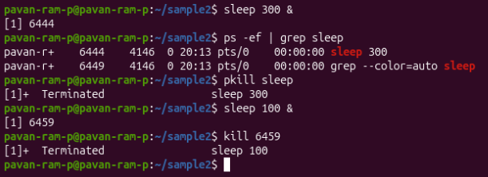

17. Install a package using the package manager (e.g., apt or yum)..
18. Update the system packages..
- sudo apt update - This command is used to check for latest updates and update the package manager
- sudo apt install <package_name or link> - This command is used to install the specified package
Note: In the below scenario, I have installed java using the apt package manager and later verified using ‘java -version’ command 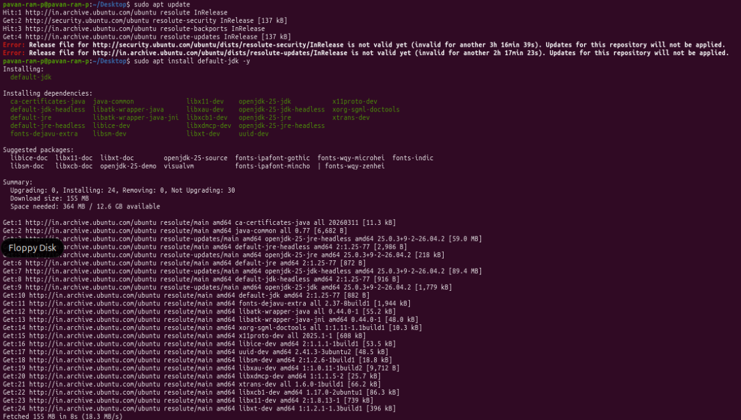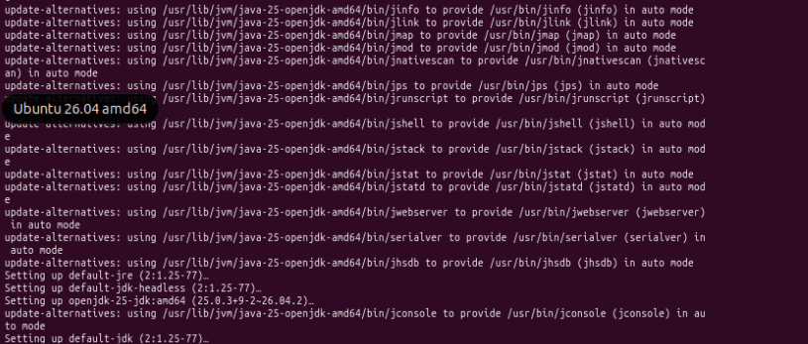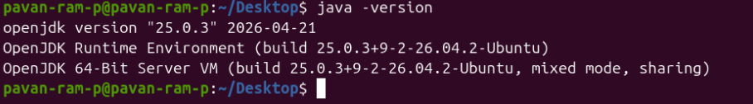

19. Create a symbolic link
- ln -s <target_file_or_directory> <symbolic_link_name> - This command is used to create a symbolic (soft) link that points to another file or directory.
Note: In the below scenario, I have created a softlink for the path ‘/home’pavan-ram-p/sample2/sample.2.txt’ with the name ‘musamplefile’.
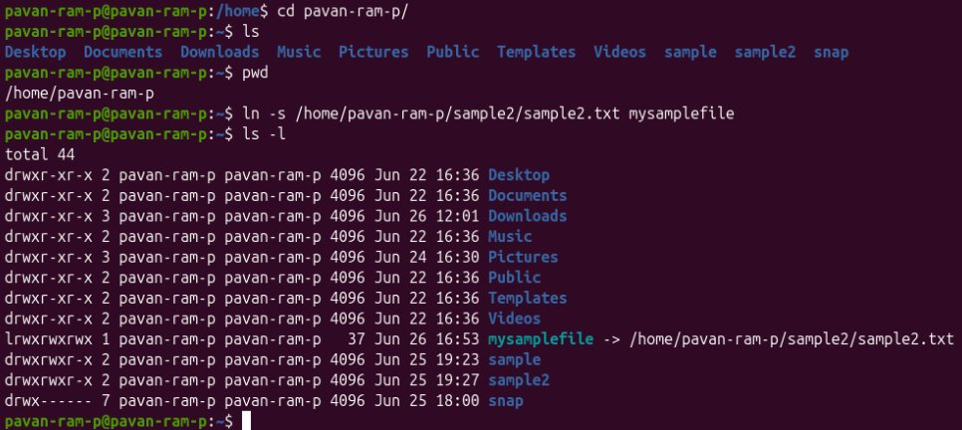

20. Search for files using the find command..
- find </path to search> -name “<filename>” - This command is used to find a file in the specified path/directory/sub-directory
Note: In the below scenario, I have used ‘find’ command to search the specific file named ‘sample2.txt’ in the ‘/home’ directory. Later I used ‘*.txt’ to find all the text files in the ‘/home’ directory.
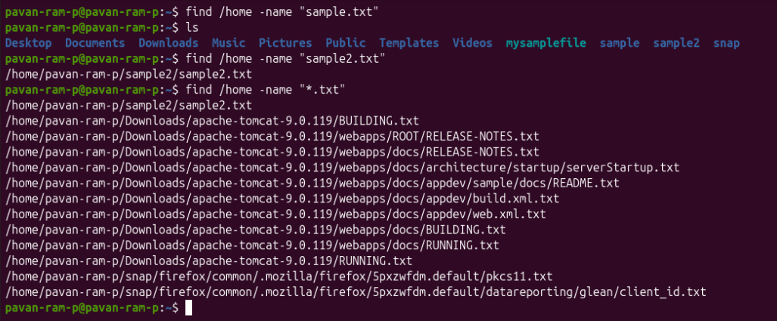
21. Compress and decompress files using tar..
- tar -czvf <archive.tar.gz> <folder_name> - This command is used to compress the specified directory/file into a ‘.tar.gz’ file/archive
  - -c : The flag used to create a new archive
  - -z : The flag used to compress the specified file/directory using gzip
  - -v : ‘verbose’ - The flag used to display the files being processed
  - -f : The flag used to specify the archive filename
- tar -xzvf <archive.tar.gz> <folder_name> - This command is used to decompress the specified directory/file and extract its contents into the current directory.
  - -x : The flag used to extract the archive
  - -z : The flag used to decompress the specified file/directory using gzip
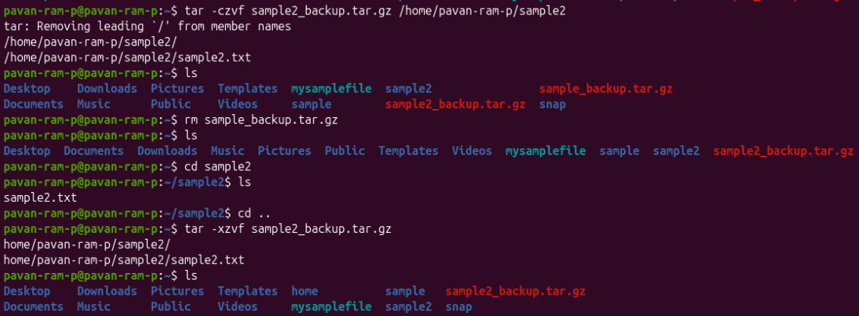

22. Monitor system resources with top or htop..
- top - This command is used to display real-time information about running processes, CPU usage, memory usage, and system load.
- htop - This command is used to display an interactive, user-friendly view of system resources and running processes.
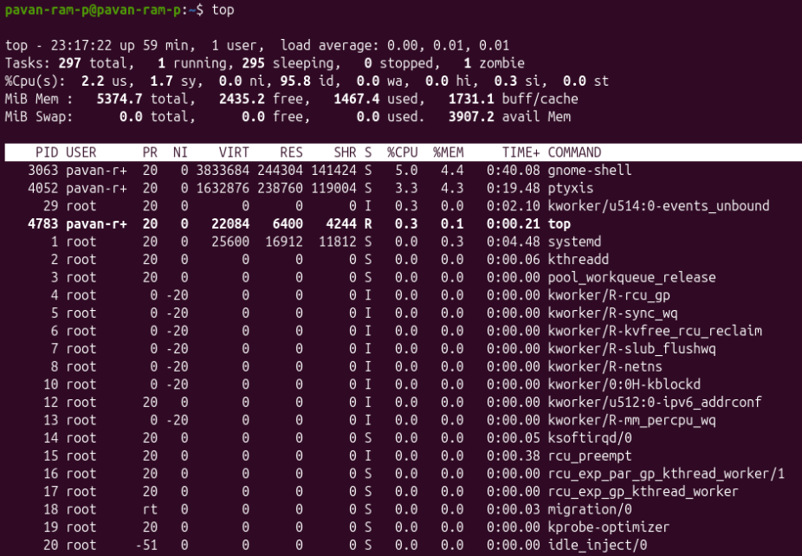

23. Create and manage user groups..
- sudo groupadd <user_name> - This command is used to add a new user with the specified name
- sudo usermod -aG <group_name> <user_name> - This command is used to add the specified user into a specified group
  - -a : The flag used to append the user without removing them from any existing groups
  - -G : This flag specifies the supplementary group(s) to which the user should be added.
- groups <user_name> - This command is used to get the groups that the specified user is present.
- Sudo groupdel <group_name> - This command is used to delete the specified group
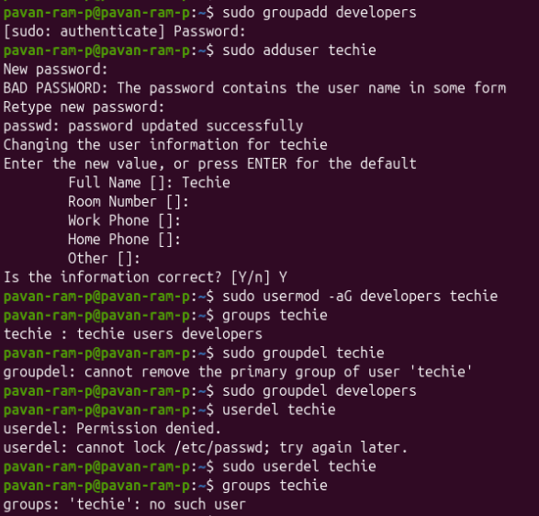

24. Set up SSH password less authentication..
- sudo apt update - This command is used to update the package repository with the latest package information.
- sudo apt install openssh-server -y - This command is used to install the OpenSSH server. It allows the system to accept SSH connections.
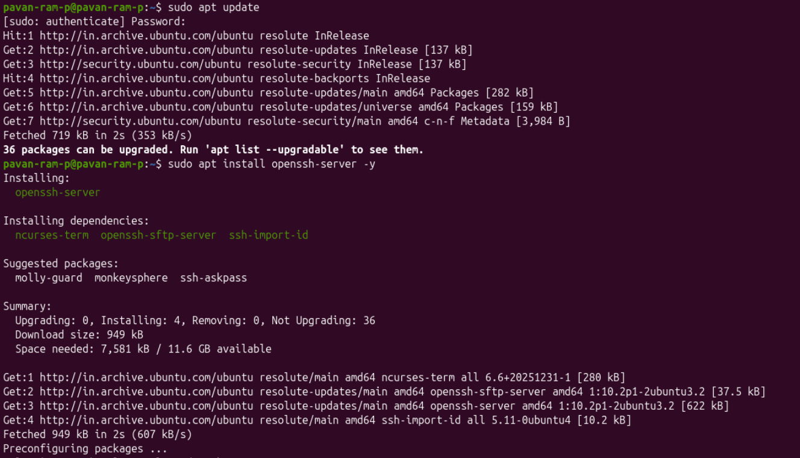
- sudo systemctl status ssh - This command is used to know the configuration details of the SSH package that is installed and verifies if ssh services are running or not.
- sudo systemctl start ssh - This command is used to start the ssh server
- hostname -I - This command is used to know the remote servers IP-Address.
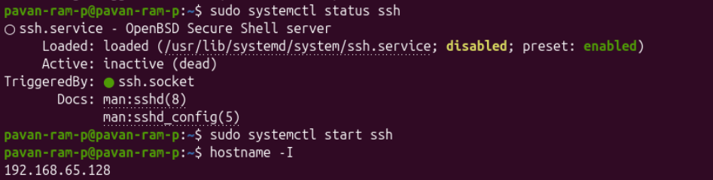
- ssh-keygen -t rsa -b 4096 - This command is used to generate a public and private SSH key pair.
  - -t → Specifies the key type.
  - rsa → Generates an RSA key.
  - -b → Specifies the key size.
  - 4096 → Creates a 4096-bit RSA key.
- ls -l ~/.ssh - This command is used to list the contents of the .ssh directory.
  - -l → Displays a detailed (long) listing.
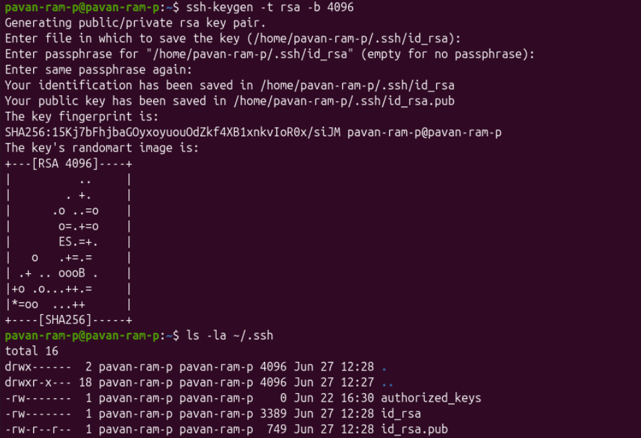
- ssh-copy-id pavan-ram-p@192.168.65.128 - This command is used to copy the public
- SSH key to the remote server's “~/.ssh/authorized_keys” file. During execution this command asks for remote server’s password followed by some prompts
- ssh pavan-ram-p@192.168.65.128 - This command is used to log-in into/connect to the remote server using the SSH key instead of the account password.
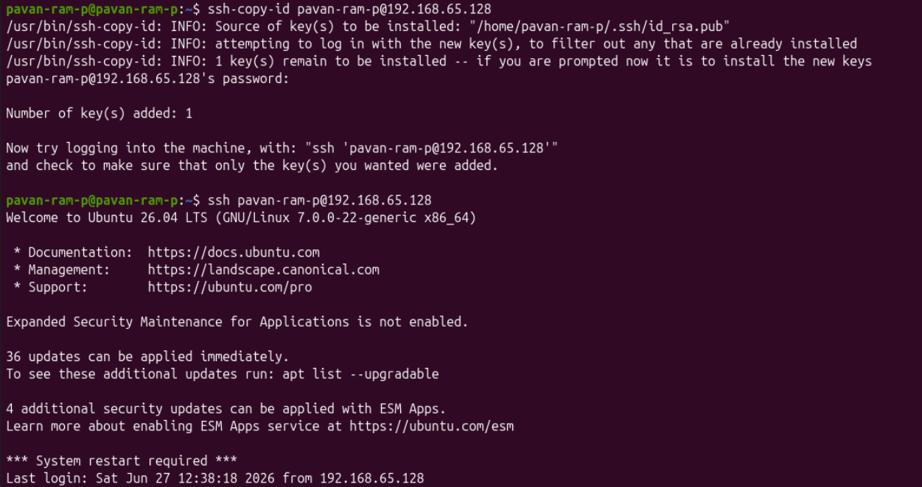
25. Monitor log files using tail or grep..
- tail <file_path> - This command is used to display the last 10 lines of the specified log file.
- grep -in “<keyword>” <file_path> - This command is used to search the log file for lines containing the keyword
  - -i : The flag used to ignore letter case while searching
  - -n : The flag used to display the line number that the keyword is present
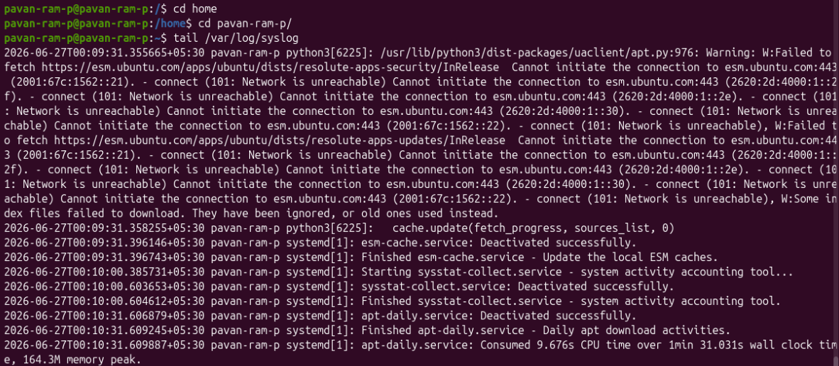
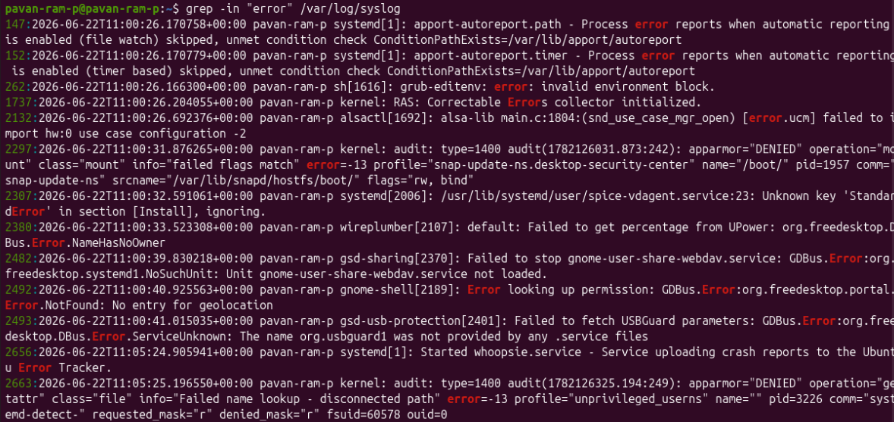
26. Set up a web server (e.g., Apache or Nginx)
- sudo apt install apache2 -y - This command is used to install apache2 packages into your system
- sudo systemctl start apache2 - This command is used to start the apache2 web server
- sudo systemctl status apache2 - This command is used to know the status of the apache server. It states weather the service is running or not
- sudo ss -tuln | grep 80 - This command is used to check if apache is listening to port 80(HTTP) ss - Command to check the socket statistics
  - -t → Display TCP sockets.
  - -u → Display UDP sockets.
  - -l → Show listening sockets.
  - -n → Display numeric port numbers.
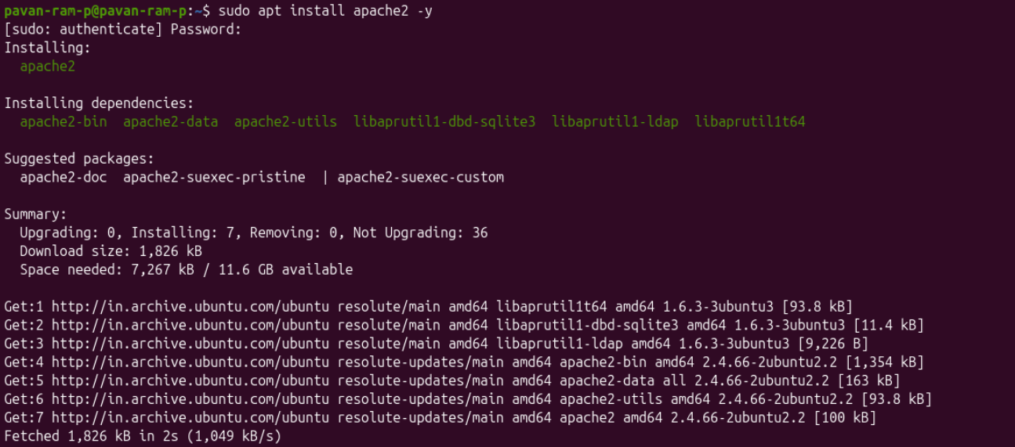
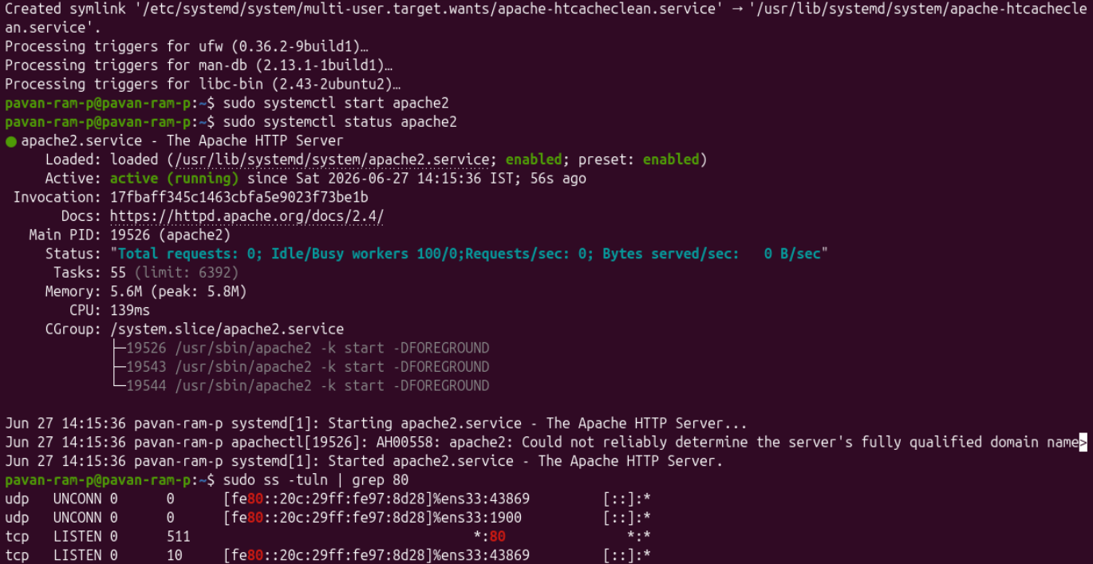
- echo "<h1>Welcome to My Apache Web Server</h1>" | sudo tee /var/www/html/index.html - This command is used to create a custom ‘index.html’ page in the Apache default web directory.
- Screenshot that the webpage is live and running.
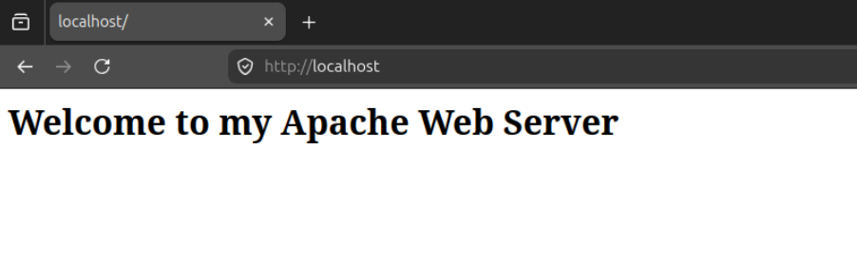
- sudo systemctl stop apache2 - This command is used to stop/terminate the web server.

27. Configure and secure a MySQL Database
- sudo apt install mysql-server -y - This command is used to install mysql packages into the remote server
- sudo systemctl start mysql - This command is used to start the mysql server
- sudo systemctl status mysql - This command is used to find all the information of the installed packages and running state of the application/web server
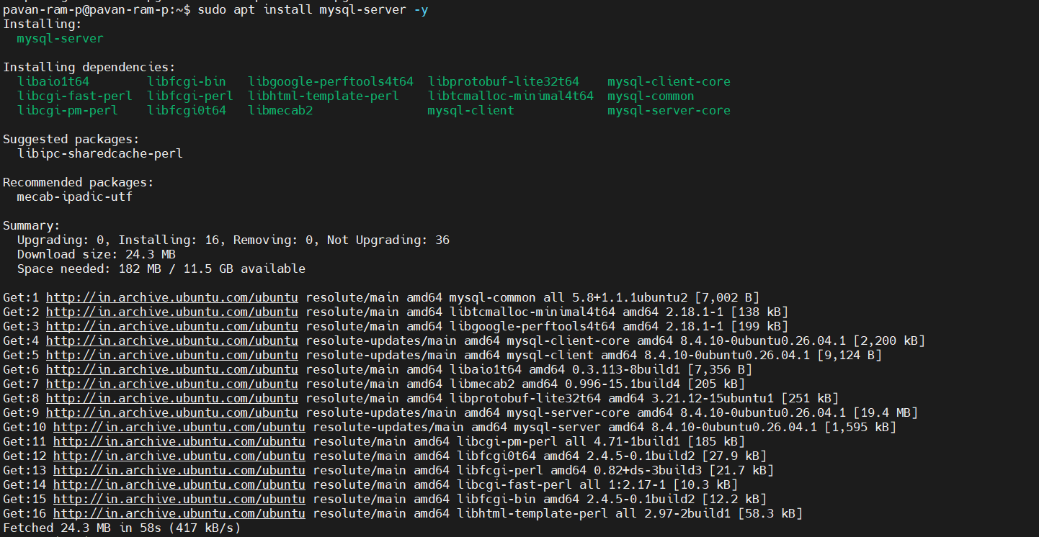
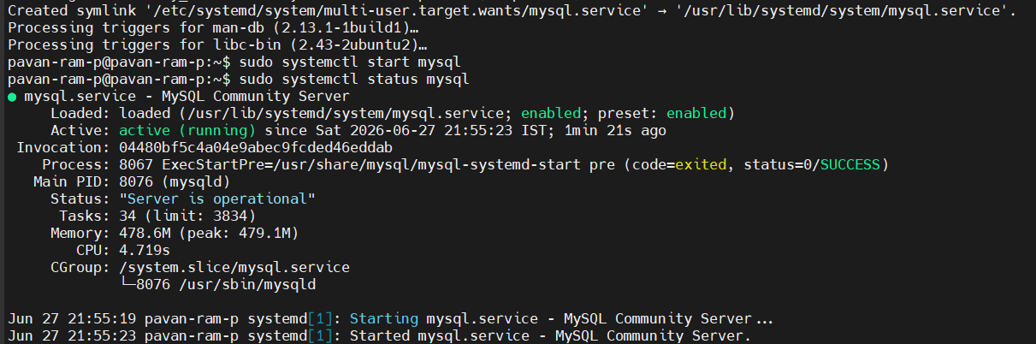
- sudo mysql_secure_installation - This command is used to run the built-in script to improve security provided by MYSQL and followed by some prompts
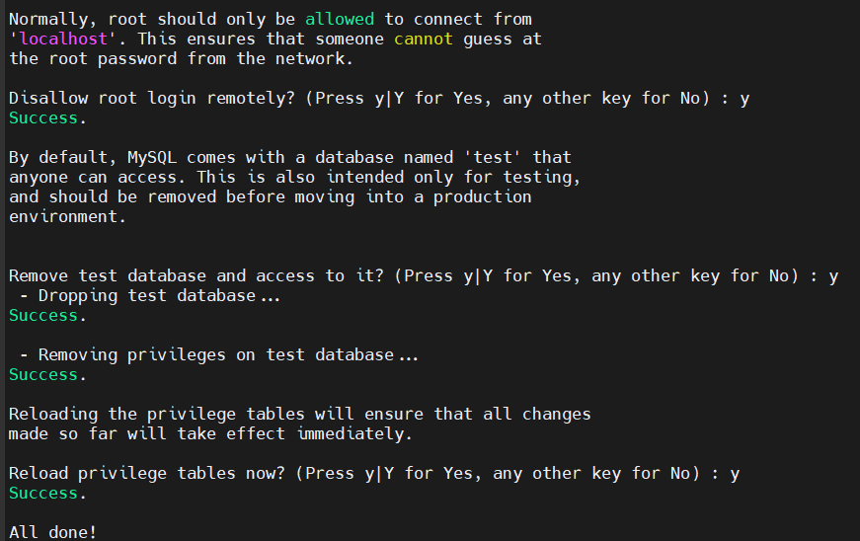
- sudo mysql - This command is used to log-into mysql
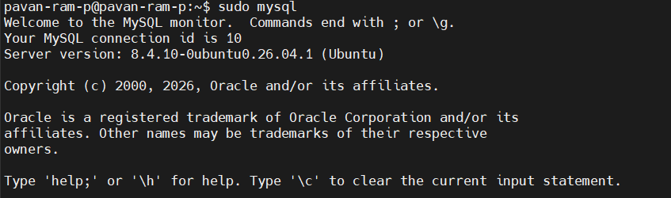
Notes: In the below screenshot, I have created a user and granted them all privileges securely.
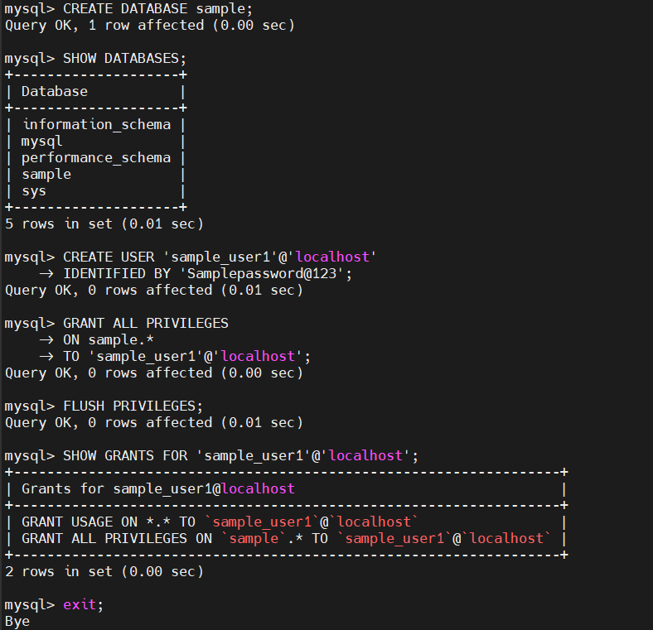
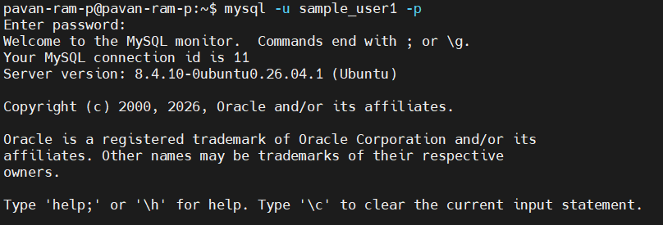
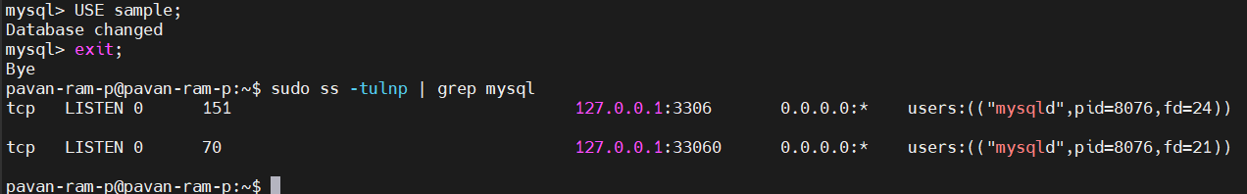
28. Set up an Application Server (e.g.,Apache Tomcat).
- sudo apt install tomcat11 tomcat11-admin -y - This command is used to install Apache Tomcat 11 along with the Tomcat Admin package, which provides the Manager and Host Manager web applications. The -y option automatically answers "yes" to installation prompts.
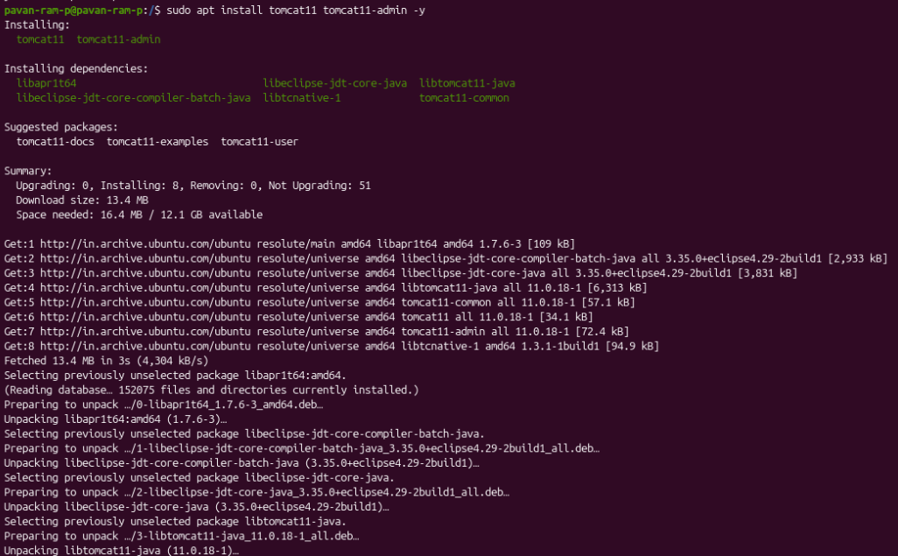
- sudo systemctl status tomcat11 - This command confirms that Tomcat 11 has been installed successfully and is running as a systemd service.
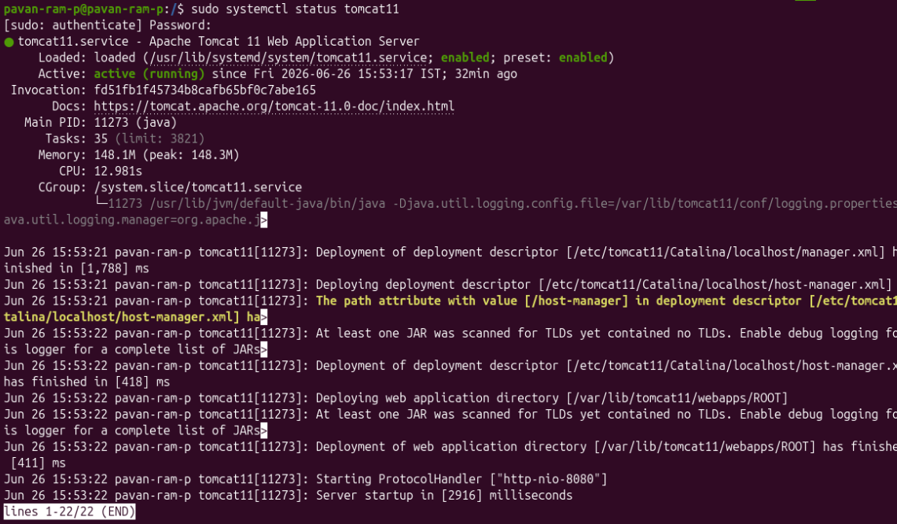
- sudo systemctl enable tomcat11 - This command is used when the user want to enable the web application server at boot
- sudo systemctl disable tomcat11 - This command is used when the user want to disable the web application server at boot
- dpkg -L tomcat11 - This command is used to list all the files installed by the tomcat11 package.
- sudo ss -tuln | grep 8080 - This command checks whether Tomcat is listening on port 8080.
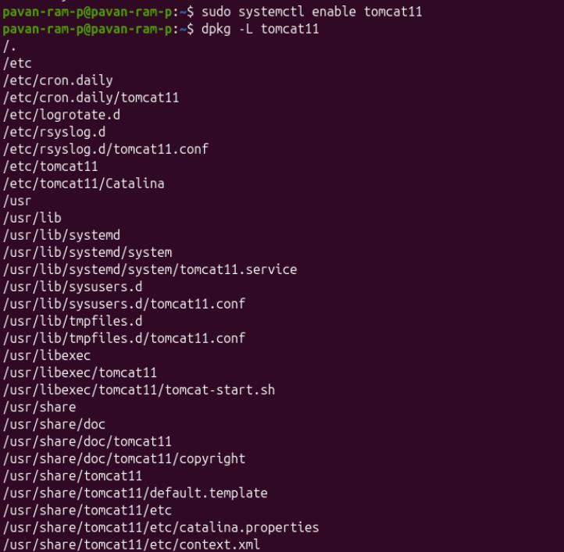
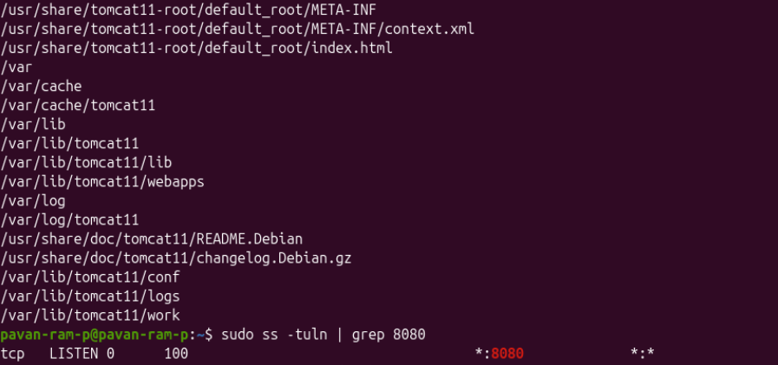

- sudo systemctl start tomcat11 - This command is used to start the web application server
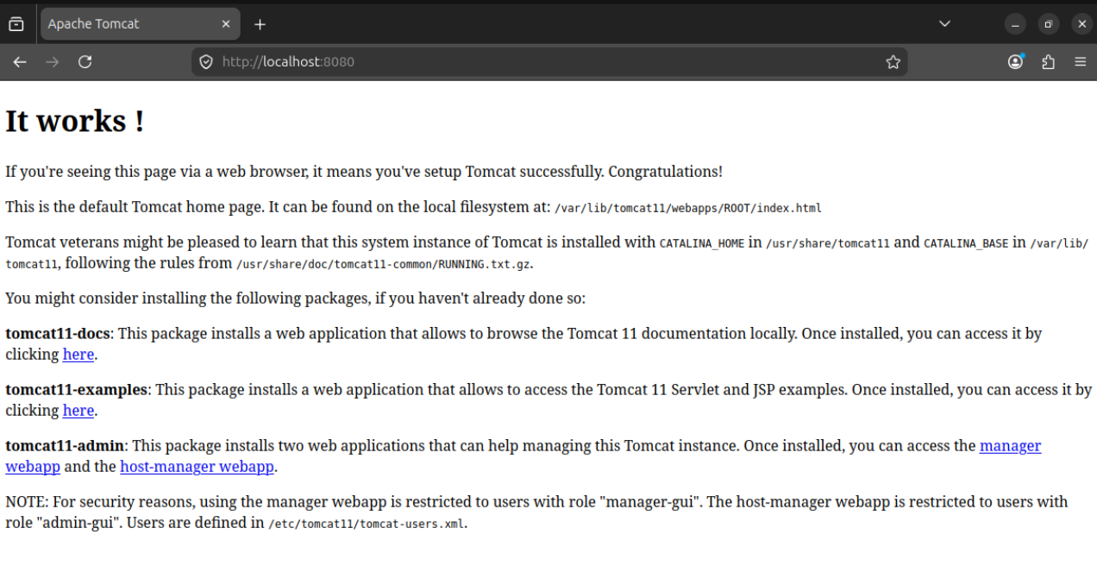
- sudo systemctl stop tomcat11 - This command is used to stop the web application server
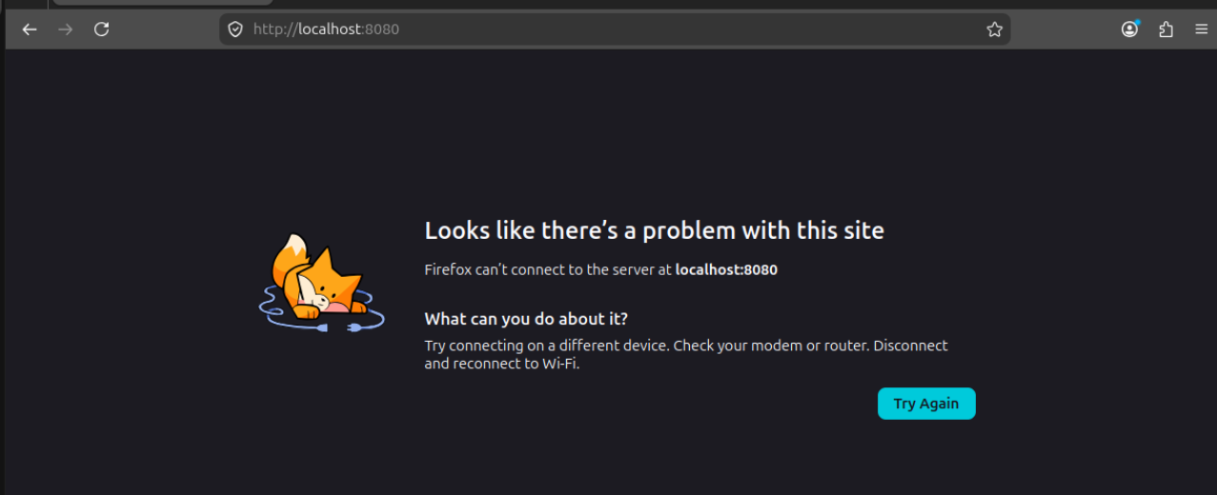
29. create a service file for Apache Tomcat.(Should execute by using systemtctl command).
- sudo nano /etc/systemd/system/tomcat.service - This command is used to create a systemd service file for tomcat.
Note: When you install tomcat11, a “tomcat11.service” file will automatically be generated. For previous versions it might vary. We can check and find it through the ‘sudo sytemctl status tomcat<version>’ command in the ‘loaded’ column.
- Add the following content into the nano file tomcat.service.
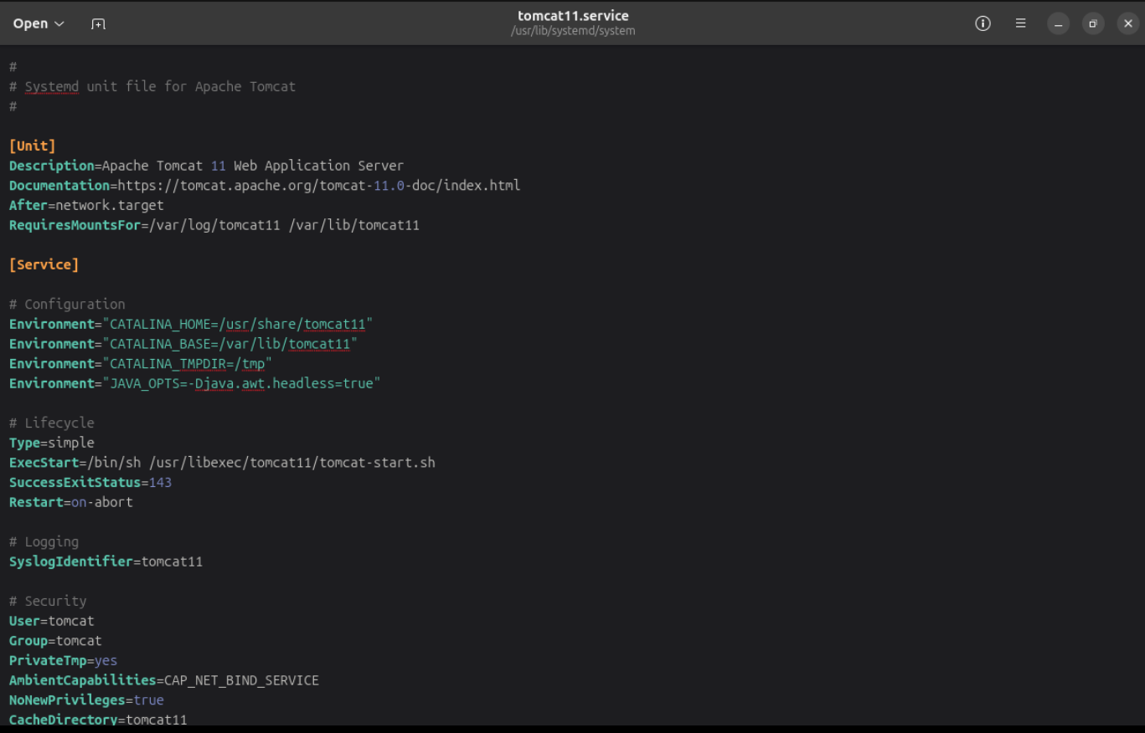
- sudo systemctl daemon-reload - This command is used to reload the systemd configuration so that it recognizes the new service.
- sudo systemctl start tomcat - This command is used to start the tomcat web application server.

30. Print specific columns from a delimited file..
- cut -d<delimiter> -f1 <file_name.txt> - This command is used to print the first column from file.txt, where the fields are separated by a colon (:)
  - -d → The flag specifies the delimiter used to separate fields.
  - : → The flag that is delimiter (colon).
  - -f → The flag specifies the field (column) number to display.
  - 1 → The flag prints the first column.
Note here are cut -d: -f1 file.txt
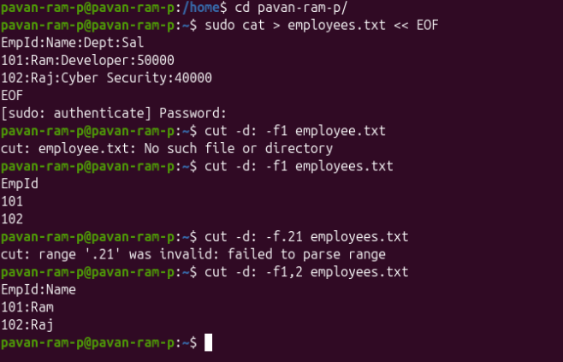
31. Filter and print lines based on a specific pattern or condition
34. Count the occurrences of a specific pattern in a file..
- grep - This command is used to search and print lines that match a specific pattern.
  - grep <word/pattern> <file_name> - This command is used to print the lines that contain the word.
  - -i - This flag is used to perform a case insensitive search and prints the line.
  - -n - This flag is used to search the lines in which the word is present and prints the line number along with the lines
  - -v - This flag is used to print the lines in which the word/pattern is not present.
  - -c - This flag is used to print the count of lines in which the word/pattern is present
  - -w - This flag is used to perform a case sensitive search and prints the line
  - -o - Prints each matching occurrence on a separate line.
  - -ci - Count Occurrences Ignoring Case
  - -cw - Count Occurrences of a Whole Word
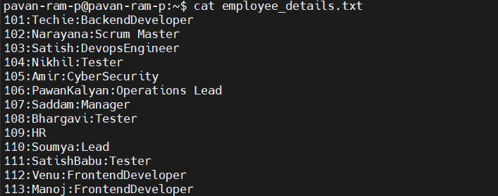
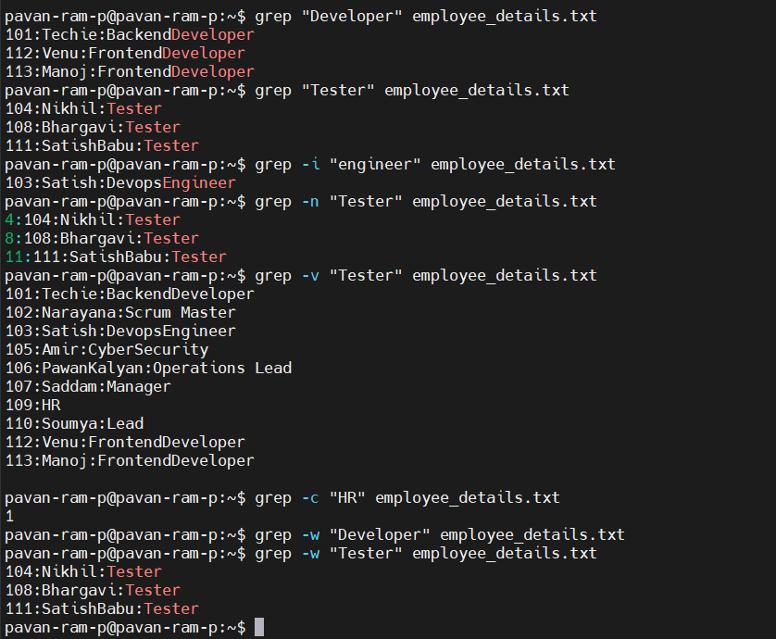
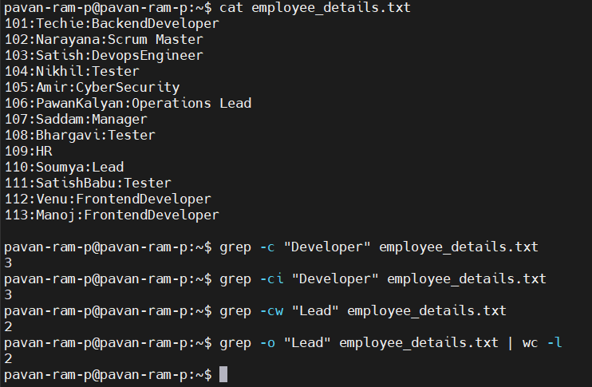
32. Calculate and print the average, sum, or other statistics of a column
33. Perform string manipulation, such as extracting substrings or changing case..
42. 5 use cases for AWK and 5 use cases for sed.
- awk - This command is used to perform calculations, manipulate strings on columns in a file.
  - BEGIN → Executes before reading the file.
  - END → Executes the command after all lines have been processed.
  - sum += $3 → Adds the value of the 3rd column to the variable sum.
  - print sum → Displays the total sum.
  - NR → Built-in variable that stores the Number of Records (lines).
  - if($3>max) → Checks if the current salary is greater than the current maximum.
  - if($3<min) → Updates the minimum salary.
  - substr(string, start, length) - Extracts the first 3 characters of the first column
    - string → Text to extract from(column).
    - start → Starting position (starts from 1).
    - length → Number of characters to extract.
  - toupper() → Converts text to uppercase.
  - tolower() → Converts text to lowercase.
  - length() → Returns the number of characters in a string.
  - “<sentence>”(Concatinate): Joins the first and second columns into a sentence.
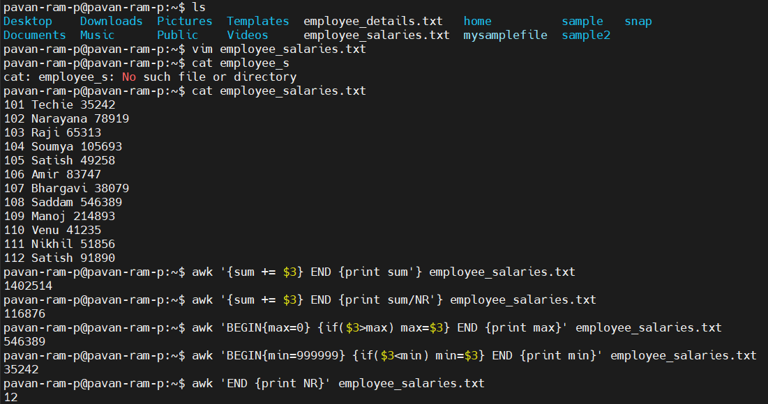
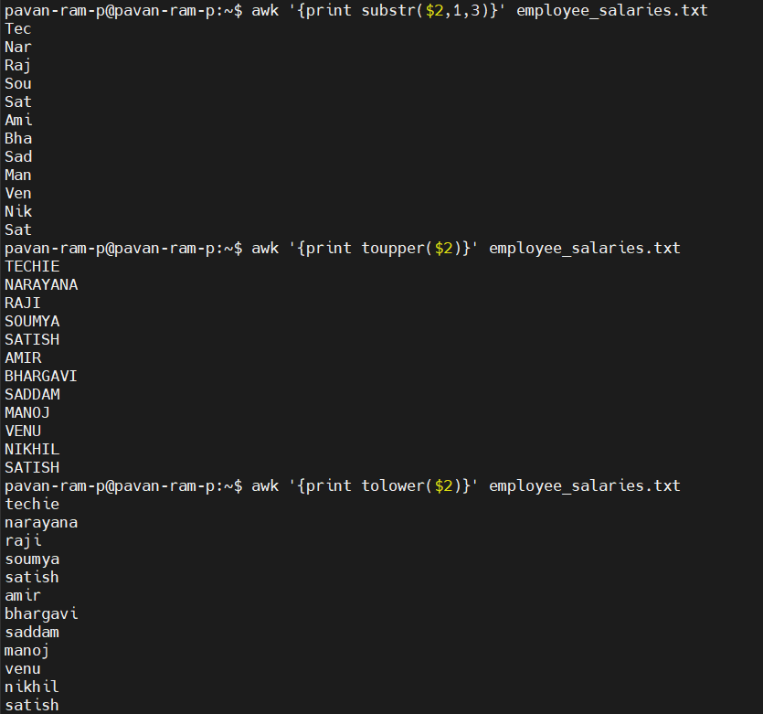
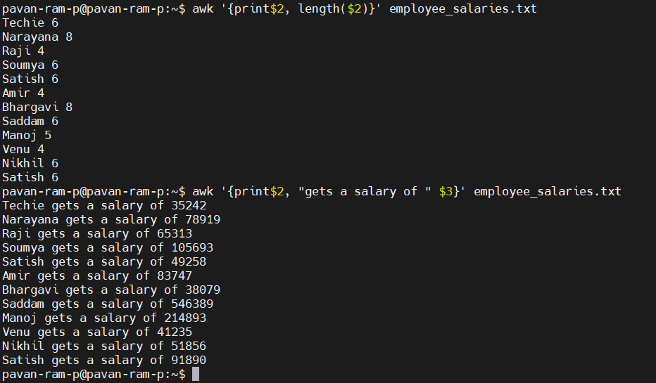
35. Sort lines based on a specific field or column
- sort - This command is used to sort the contents of a file alphabetically, numerically, or based on a specific column.
  - -k1/k2/k3 - These flags represent each columns, sorts the specified column alphabetically
  - -n - performs a numeric sort
  - -r - reverses the sorting order
  - > - redirects the output to a new/specified file.
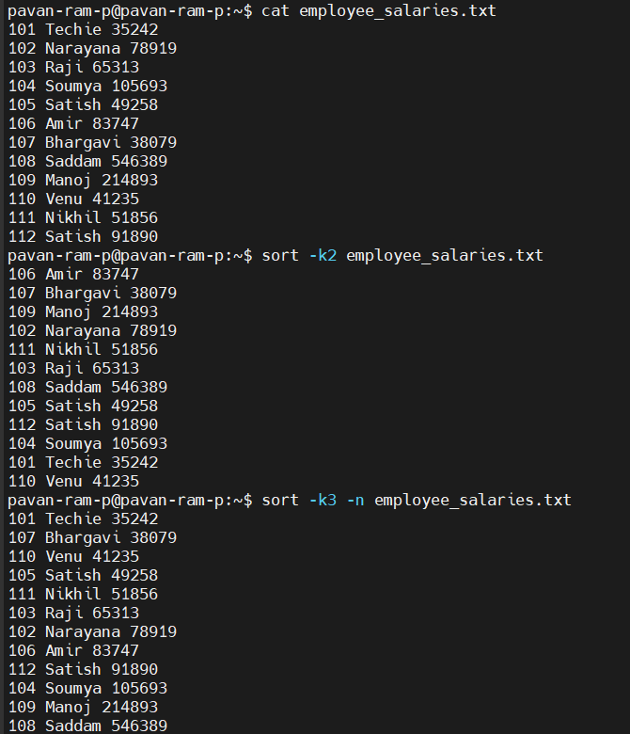
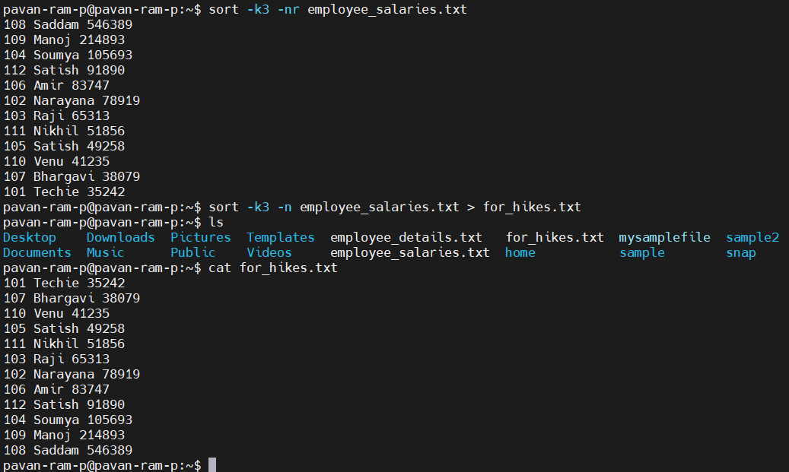
36. Merge multiple files based on a common field or column
- join - This command is used to merge two sorted files based on a common field (column).
  - sort -o <file_name> - writes a sorted output to the specified file
  - join <file1> <file2> > <new_file_name> - merges file1 and file2 into a new_file.
    - > - This flag is used to redirect the output to a file
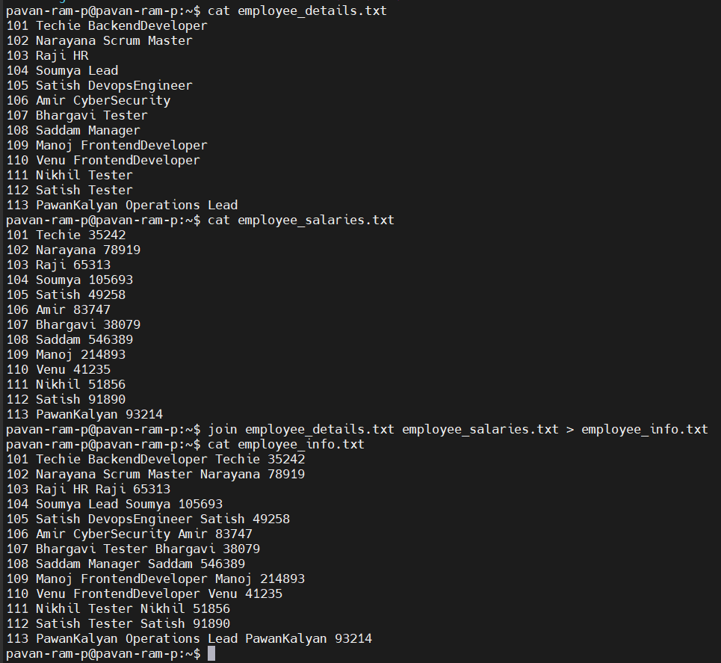
37. Substitute text in a file using search and replace
38. Delete specific lines based on a pattern or line number
39. Append or insert text before or after a specific pattern or line
40. Print only specific lines from a file..
42. 5 use cases for AWK and 5 use cases for sed.
- sed ‘s/<actual word>/<replacement/>’ <filename> - (Stream Editor) - This command is used to search for text in a file and replace it with new text.
  - s → This flag indicates a substitute (search and replace).
  - -i → This flag indicates to edit the file in place.
  - g → This flag indicates to replace all occurrences in each line.
  - I → This flag ignores the case while matching.
  - d → Delete the specified line.
  - i → Insert text before the specified line.
  - a → Append text after the specified line.
  - p → Prints the specified line.
  - -n → Suppresses the default output.
  - 3 → Specifies line number 3.
  - 2,4 → Specifies the line range.
  - $ → Represents the last line.
  - 1~2 → Starts at line 1 and prints every 2nd line.
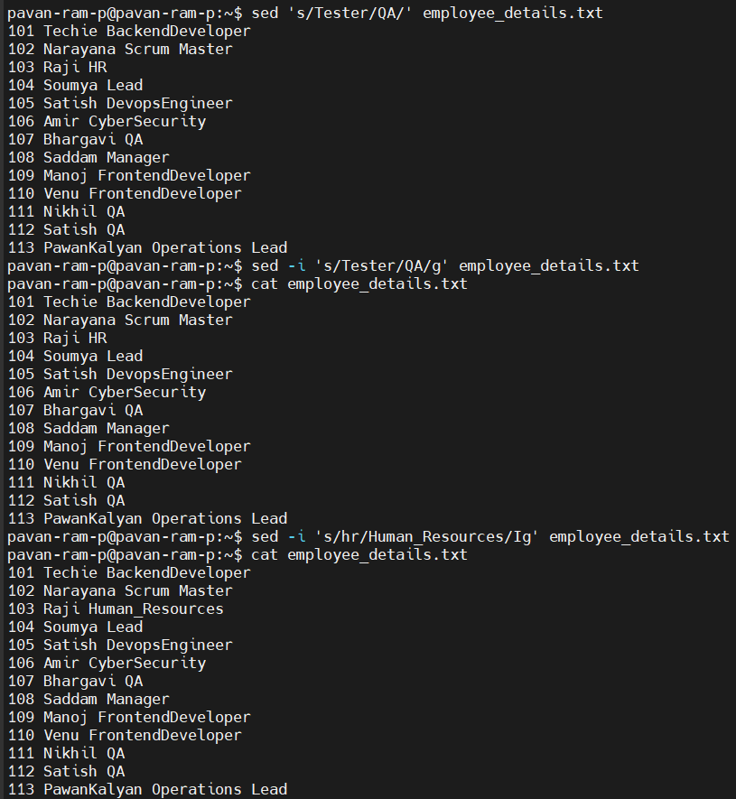
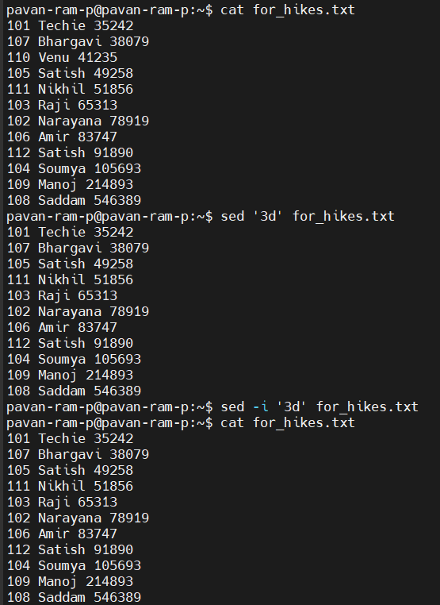
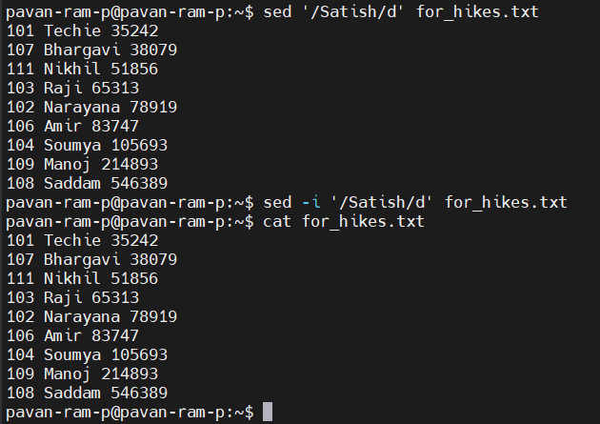
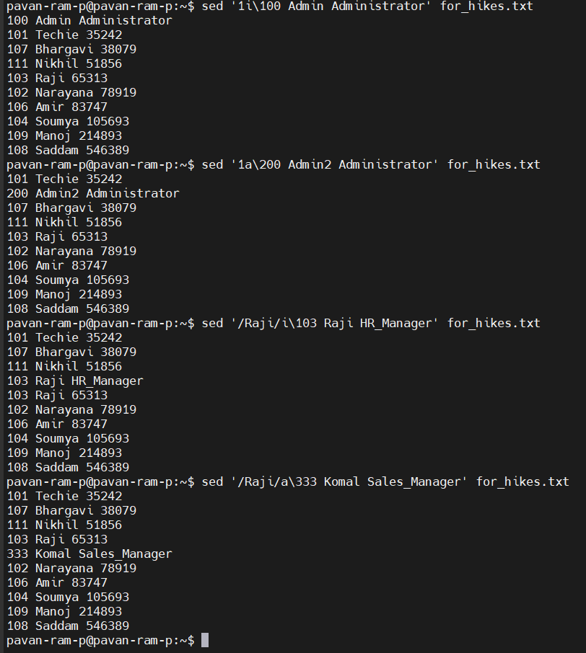
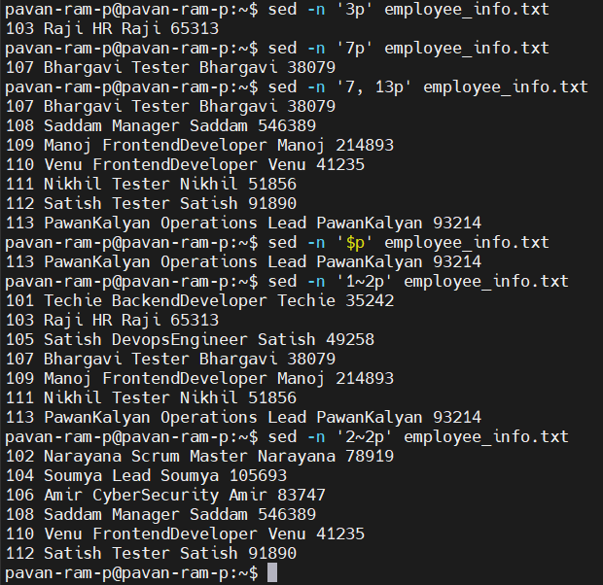
41. Copy file from linux to windows machine.
- scp - (secure copy) →
scp report.txt username@192.168.1.20:C:/Users/username/Desktop/
  - scp → Securely copies files over SSH.
  - username → Windows account username.
  - 192.168.1.20 → Windows machine IP address.
  - C:/Users/username/Desktop/ → Destination directory on Windows.

